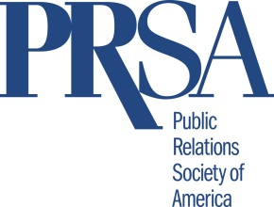
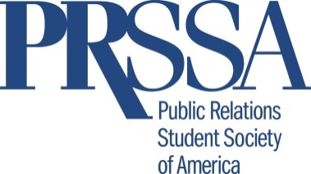

Checklist for PRSSA Liaisons

The PRSSA Liaison is typically the PRSA board member that serves as your PRSA Chapter’s connection to your PRSSA sponsoring school(s). They keep track of your PRSSA Chapter(s) each school year. Please share the checklist below with your PRSSA Liaison. If you do not have a PRSSA Liaison we encourage you to consider adding this position to your board.
- Make a contact list of the Faculty Adviser(s), Professional Adviser(s) and Chapter. president(s) at the PRSSA Chapter(s) sponsored by your PRSA Chapter.*
  - If the Professional Adviser position is vacant, help the PRSSA Chapter(s) appoint/recruit one (see page 14 of the PRSSA Chapter Handbook).
- Schedule an introductory phone call, or visit the PRSSA Chapter(s) on campus.
- Ask for the PRSSA Chapter(s) meeting schedule.
  - Try to attend at least one meeting annually.
- Invite students to your Chapter’s events or meetings (offer students a special rate).
  - Work with student Chapter(s) on professional development and networking events and invite them to attend your programs and events, when appropriate.
- Plan periodic check-ins with the Faculty Adviser(s) and president(s) (mid-term and end of term of academic semester).
- Develop a process to keep the Faculty Adviser(s) and Chapter president(s) aware of your Chapter’s initiatives and news.
- Share the PRSSA Chapter(s) initiatives and news with your Chapter members.
- Be a resource for speaker recommendations and other requests for assistance.
- Encourage graduating seniors to join PRSA as Associate members for the discounted rate of $60. Consider donating PRSA Associate membership to outstanding PRSSA members.
- Coordinate an event with your PRSSA Chapters to celebrate PRSA/PRSSA Relationship Month every October.
*If you are unsure of the school(s) your Chapter sponsors please see attached list.
Contact the PRSSA National Faculty Adviser, Tina McCorkindale, Ph.D., APR, at tinamccorkindale@gmail.com and/or the PRSSA National Professional Adviser, Kelly Davis, APR, at kelly@davispublicrelations.com with any questions.

