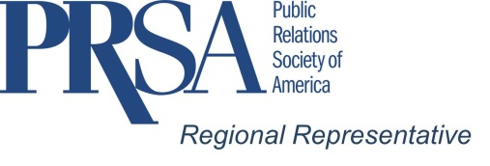
David L. Shank, APR, Fellow PRSA
Finding the perfect Chapter speaker – if there is one!
A Chapter Program Chair Listicle

Programs are the heart and soul of your Chapter success. Through your speakers and programs you have to provide your chapter members with the “what’s in it for me?” answer, “the why should I spend my time with PRSA” and finally, “how do I justify the time and money with my boss.” There are no easy answers but here are some thoughts:
- It takes more than someone who talks and breathes.
- What does your Chapter want or need to hear? Have you surveyed their interests?
- What are the demographics and psychographics of your chapter? Programming for Millenials is different than for Masters.
- Look outside the public relations business. There’s a reason “public” is in our name. What key community issues are happening that your members should know about?
- Be topical and current – a strong community event with public relations ramifications could pop up at a moment’s notice – be ready to take advantage of hard news.
- Don’t be afraid to have fun at meetings and, have fun and meaningful speakers.
- Look at your own members for extraordinary discussions. Has a member completed a project, a special trip, solved a major problem for their client, company or institution; been involved in super-special activity? What can your chapter members learn from it?
- What new dimension can you bring to your membership? A new way of viewing the world?
- Look to community resources: Is there a university in your community that has a variety of subject matter experts masquerading as professors and teachers? For example, in the past election, the winning candidate blew away market research, surveys and polling data. Without getting political, what did pollsters learn and what can we learn from the election research – positive and negative?
- Another example: in the East Central District a major university has a CSPAN Fellow with in-country Afghani, NIH and government crisis management experience. She wants speaking gigs.
- Take advantage of theme months such as “Diversity Month” but don’t limit your discussions to that month alone.
- Engage members at all levels. Even the newbies and youngest members can contribute to panel discussions.
- The one all-time across-the-board crowd grabber and luncheon pleaser are Media Panels with reporters from your local news media.
- Don’t get carried away with “social media” programs. People are getting burnt out on this topic.
- Don’t program just for what you like.
- Evaluate speaker performance with follow-up surveys to your members and pass the results on to future program chairs.
- Share your programming ideas and speakers with other Chapters and Districts through the Chapter and District MyPRSA online communities.
(30)
March 8, 2017
Bio:
David L. Shank, APR, Fellow PRSA has been a PRSA member since 1977. He has served as Hoosier Chapter Chair, Chair of the East Central District and served on the East Central District Board twice. In 2016 he was commissioned by PRSA to work with the East Central and Midwest districts as a PRSA Regional Representative. His company, Shank Public Relations Counselors, Inc. is headquartered in Indianapolis.

